# Failure and Interruption: Creative Carers in a Time of COVID-19

### Julienne van Loon and Kelly Hussey-Smith

## Introduction

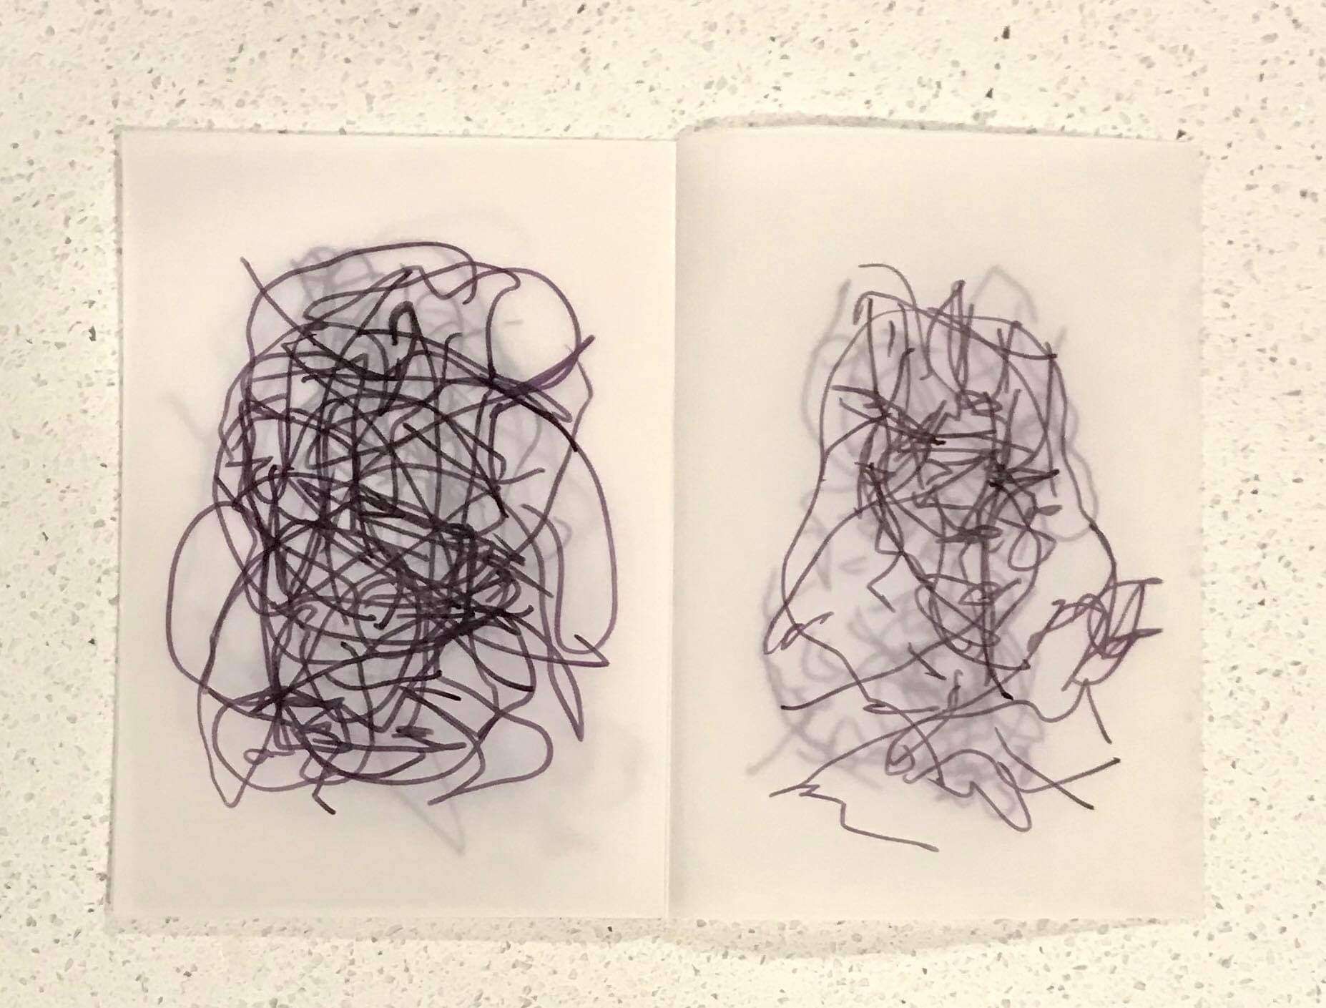

Figure 9.1: Participant C’s map of their domestic space while working and caring from home.

Recent research indicates that parents and carers were interrupted up to 15 times per hour while working and caring from home (WCFH) during the COVID-19 pandemic.[1] In this chapter, we explore the relationship between interruption and senses of failure as experienced by 22 creative practice researchers in the context of WCFH between March 2020 and October 2021 in and around Melbourne, Australia. We ask: what affective impact has the intensification of ‘work’s intimacy’[2] had on creative industries researchers working and caring from home during the intense ‘lockdown’ phases of the COVID-19 pandemic? How have constant interruptions affected their capacity to maintain continuity in their intellectual and creative work? Further, how have the senses of failure widely reported by those WCFH been articulated and expressed through creative methods?

We use the phrase ‘work’s intimacy’ in the sense employed by media studies scholar Melissa Gregg to describe and ‘demonstrate the increasingly intimate relationship salaried professionals have with their work’ and in particular the role of new media technologies in that development.[3]

Our chapter begins with a concise overview of recent literature on failure and interruption during the time of COVID-19. We then provide a brief outline of the methodology and methods we have employed to address our key questions in this study. We consider the domestic as a space interrupted under the pressure of work’s intimacy during periods of WCFH. Through discussion and analysis of data collected through the Work, Care and Creativity Study[4] we explore perceptions of failure among participants with a focus on how these perceptions relate to real and perceived interruptions to their careers and creative work. Finally, we discuss adaptation and adaptiveness, exploring the possibilities for an affirmative political reading of failure and interruption.

## Failure and Interruption

There have been mixed debates about the impact of working and caring from home. For some creative workers it was ‘a surprisingly creative time’,[5] but for many it was a difficult and debilitating phase of work and family life. Australian research published since the arrival of the pandemic has shown that women ‘continued to shoulder the burden of unpaid domestic and caring work’[6], raising concerns about a significant worsening of existing inequalities in the workforce. The negative impact on women in academia has been notable, with many studies confirming reduced productivity[7] and a negative impact on career momentum.[8] Further, workers in the arts and creative industries were particularly vulnerable to career disruption during COVID-19, and this was especially so in Melbourne, Australia, where our project participants were based, and where lockdown conditions were among the world’s most restrictive.[9]

While precarity in the arts and higher education sectors in Australia pre-dated the pandemic[10] and working parents and carers are not new to career disruption, the pandemic enabled a perfect storm. The intensification of work’s intimacy kept prescient the feeling that these ‘new’ conditions may have no end.[11] Among the 22 participants in our study, WCFH led to increased anxieties about failure, sparked in large part by the perception that focus of any kind for an extended period was no longer possible. Lived experience, for those WCFH during COVID-19, was life perpetually interrupted.

Large scale studies conducted prior to COVID-19 found that constant interruption was a key source of stress at work[12] and that knowledge workers are interrupted on average 85 times per day.[13] Related international studies have indicated that frequent interruptions have a negative impact on emotions, wellbeing, and performance[14]. The constant interruption while WCFH during the pandemic was cited consistently among our participants as a source of stress and anxiety about the future.

For psychosocial theorist Lisa Baraitser, interruption is not a deviation but the norm for the maternal subject.[15] Similarly, gender and equality studies scholar Moynag Sullivan observes that creative work that engages with an aesthetics of interruption rethinks the possibilities of subjective experience by ‘bear[ing] witness to the fragmented, interrupted consciousness of the mother’.[16] For scholar and artist E.L. Putnam, an aesthetics of interruption encompasses an ethics where ‘breaks, jagged edges, absences, silence and noise are not glossed over through illusions of perfection but these qualities point to the glut of experience and how it exceeds the limits of representation.’[17] Our study proposes that surfacing the affective dimensions of these interruptions places value on the fragmented, affective, and invisible aspects of care labor.

Building on Gregg’s notion of work’s intimacy, we propose that the relational intensities of the pandemic created new forms of ‘intimacy work’ where many people experienced an accelerated sense of failure around the daily demands of life and labor, which significantly disrupted creative and academic work. As queer and feminist theorists have highlighted, the Western concept of failure is bound up in capitalist value systems and binary thinking,[18] which leads to individualized conceptions of failure that don’t recognize how failure is ‘institutionally contextualized and cooperatively understood’.[19] While we acknowledge that failure has ‘subversive potential’,[20] we also recognize that it is painfully experienced, particularly when framed as an individual problem. Our work aims to surface the intangible affects and residues that emerge from this sense of individual failure, understanding that collective failure can make a productive contribution to feminist subjectivity.

## Methodology and Methods

During 2020 and 2021, we collaborated with digital ethnographers Larissa Hjorth and Gretchen Coombs on the Work, Care and Creativity Study.[21] The aim was to understand the experiences of primary carers working from home, specifically carers who were creative arts practitioners associated with the university sector. We were interested in deploying creative practice ethnography techniques to elicit participants’ lived experiences of WCFH during the pandemic. These methods enabled our participants to articulate often overlooked perceptions and experiences through creative writing, drawing, and photography. The call was circulated on social media through snowballing (contacts of contacts) in early 2020. Twenty-two participants responded to creative prompts and we followed up on their submissions with narrative interviews. This mixed methods approach provided insights into the affective experience of during the pandemic. Here, we draw on the creative prompts and the interview material we collected in order to discuss and analyse senses of failure and their relation to extended periods of constant interruption.

In our study, many participants expressed a heightened sense of precarity and fear about the future during their time WCFH. This was likely exacerbated by the fact that project participants work in industries that, in addition to being precarious, often demand additional and invisible labor.[22] An inability to perform this additional labor disadvantages those with caring roles — a reality that disproportionately impacts women and was exacerbated by the pandemic.[23] The sense of failure experienced by many working parents and carers during COVID-19 brought these gender and caring inequities into view.

Playful and modest forms of creative practice — in the form of brief prompts — offered our participants the opportunity to express humor, irony, and forms of feminist resistance that acknowledged failures small and large by giving expression to competing subjectivities and tacit labor under difficult conditions. Our lived experiences as creative academics working and caring from home in the longest locked-down city in the world[24] influenced the framing and interpretation of our research. This included bringing humor and care to the research process and acknowledging our limits at a time of constant interruption. Modes of humor that found expression through this project made possible a shared recognition of collective fears and anxieties about the status quo, particularly its potential to be maintained by patriarchal and labor market forces. Shared career and parenting failures and a heightened sense of irony around everyday failure, in this context, became something our participants could draw on to create a sense of hope for an affirmative politics.[25]

## An Aesthetics of Interruption: The Spatial and Relational Intensities of the Home

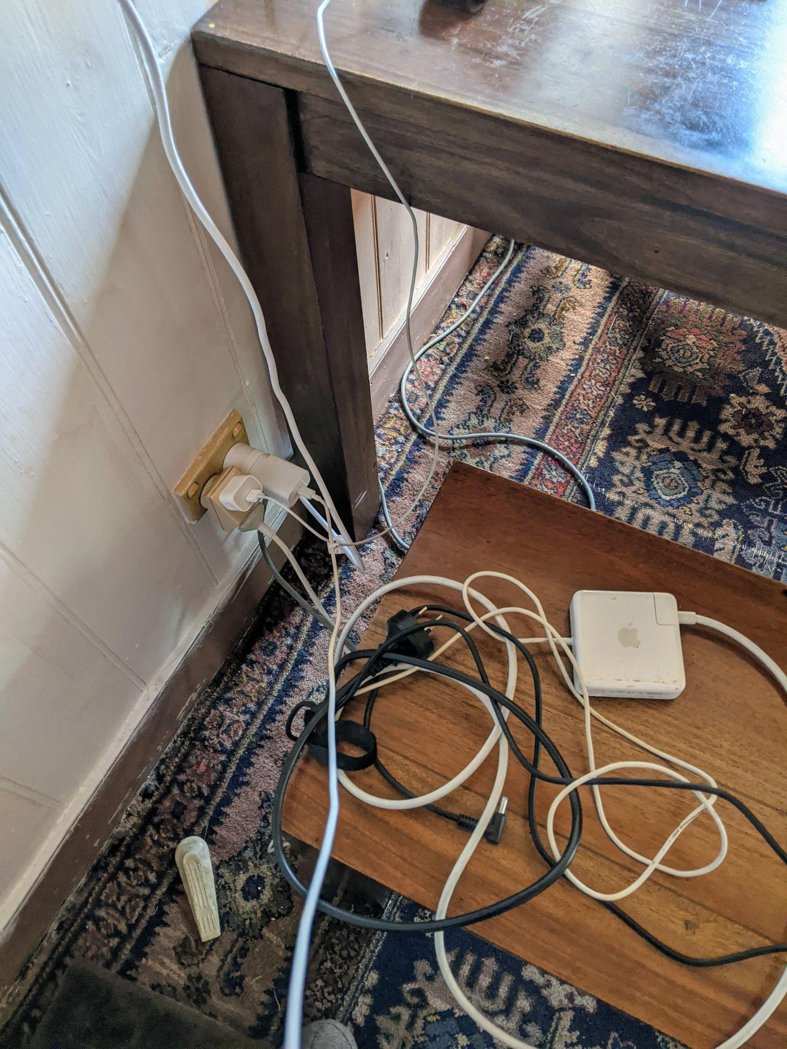

Figure 9.2: Participant E’s response to ‘work/life balance’ while WCFH, 2020.

One of the creative prompts we produced asked for a description, sketch, or photograph of the improvised home workspace during the height of Melbourne’s COVID-19 lockdown. During this intensive phase, the space of ‘the office’ at home, often improvised and shot through with the noise and movement of children, appeared in participant responses as a site interrupted. One respondent, in her creative writing prompt, wrote, ‘my office is a magic trick, an illusion.’ Figures 9.3 and 9.4 represent additional responses to this same prompt.

In the background of my ‘office’ — which cannot be shut to the rest of the house — is the noise of two seven-year-old girls. It is the last day of school holidays and I feel like a husk. They are supposed to be keeping quiet, but they are not. Some sort of argument is bubbling and so my ears are pricked up, my body coiled for intervention.

Figure 9.3: Participant A’s response to our creative writing prompt while WCFH, 2020.

I have a door. I have a lock. But sound carries. There’s a big gap at the bottom of my door that my eldest slips notes under. They can’t write yet, but there’ll be letters and drawings. The gist of the notes is always: come out. Sometimes the notes are angry, with a picture of me at my desk with a cross through it. Sometimes the notes have love hearts, things that say I love you, I miss you. Sometimes they just yell at the door.

Figure 9.4: Participant B’s response to our creative writing prompt while WCFH, 2020.

Those participants who responded to the prompt visually, as seen in Figures 9.1 and 9.2, foregrounded forms of fragmentation, intensity, or disruption that commonly accompany digital technologies. The cumulative effect of constant and persistent trespasses at the edges of the improvised ‘workspaces’ while WCFH is a noticeably negative impact on the kinds of thinking or practices that could be performed there. Forms of improvisation or ‘making do’ were also emphasized in the creative prompts we collected, underlining a setting in which caring is also present, such as the precariously balanced laptop in Figure 9.5, where the presence of domestic chores lies somewhere just beyond view.

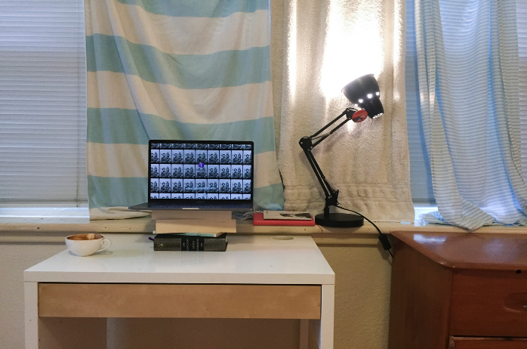

Figure 9.5: Participant J’s workstation while WCFH, 2020.

Our research demonstrates that the confidence with which those WCFH can ‘hang on’ to their critical thinking skills or creative practice is impacted by their WCFH circumstances. This also affects their hopes and plans concerning career continuity, career development, and major creative or intellectual work. As one participant expressed in her interview:

I think what is more difficult to communicate is, is the sense of, I could kind of tear up thinking about it, but I think it’s not even the mechanics of the idea that you’re going to be interrupted or that you might be interrupted. It’s what it actually kind of does for any deep work, which might be a relationship or yourself or a creative work or critical [work] or being responsive to another human in a work way, you know, any, any deep engagement I think becomes compromized. [Participant Q, interview, 2020]

In Figure 9.1, the scribbled ‘maps’ of the improvised WCFH space offered to us by Participant C provide an absurdist take on the working carer’s subjective experience of the lockdown. There is no guidance in this map: meaning has broken down. Overlapping lines of text could be the rough play squiggles of a child who took hold of the pen in an act of defiance just at the wrong moment; alternatively the lines may show the negative impact of interruption on the carer’s emotional state.[26] This is an instance of artwork that, as Putnam observes, challenges our desire for coherence, giving us instead ‘a sensory experiential phenomenology of co-being in which “the forward thrust of our lives” is interfered with’.[27] In this way, it is also an instance of Sullivan’s aesthetics of interruption and emblematic of the lived experiences of many participants in our study. In follow up interviews, our participants spoke at length about the problem of interruption. This flags a deepening concern about how WCFH periods, still being experienced by many of our participants as we finalize this chapter in 2022, will impact their intellectual and creative work and their well-being into the future.

## Perceptions of Failure

While some participants spoke about ‘frantically’ producing creative work, or productively adapting to their limitations, others saw a complete erasure of this part of their life. For some, the erosion of time for academic and creative work was compounded by an internalized and ubiquitous sense of failure:

I totally failed at the PhD […] I had no mental space, no emotional space, it just became this big black abyss, that I felt like every day went by, I was failing even further. [Participant E, interview, 2020]

And:

I know I’ve failed at my creative work: I’ve not even attempted it once. [Participant D, interview, 2020]

As one participant remarked about the challenges of home schooling a young child, ‘it was like having a baby again, I couldn't do anything. Whilst I was with him, I couldn't do anything for myself’ [Participant J, interview, 2020]. This feeling of *stuckness* relates to other participant responses that detailed the frustration of living in the fluidity and *unfixedness* of domestic space.

Figure 9.6 shows how Participant A perceived ‘accusing’ objects that sat beyond the flimsy boundary of the screen; while in Figure 9.7 Participant F highlights the competing modes of co-presence within the home by commenting on the aesthetic shifts caused by the pandemic.

To the left of my desk sits the cat litter tray. To the right, the laundry basket is accusing me with laundry. Everywhere I look there are other things I have to do.

Figure 9.6: Participant A’s response to our creative writing prompt while WCFH, 2020

Each day there are new things in the hallway […] I refrain from comment because I don’t care and I don’t want to discuss the pile — it’s like a social experiment except the pandemic is real and it brings stuff out of people’s bedroom and into the hallway.

Figure 9.7: Participant F’s response to our creative writing prompt while WCFH, 2020

Other participants commented on the gendered tropes of domesticity and childcare that bled into professional spaces. A number of them spoke about the complexities of ‘opening’ their home to colleagues and students. Participant R described how she arranged her Zoom background to avoid any sign of domestic work or childcare stating that she didn’t want people to ‘see what I'm doing or even associate me in my professional life with domestic chores’ [Participant R, interview, 2020].

Humor helped participants to cope. Participant G’s response to our creative prompt to write a set of instructions on how to get through the day at home while balancing work and domestic and emotional labor is presented in Figure 9.8.

1. Login to the X as Y. Login to the Y as Z. Login to the E on behalf of F, then log into the usual place as yourself.

2. Your password is incorrect. Please reset your password. Your username is incorrect. Please find your username. Sorry, please contact the school administrator. You've been locked out of the system.

3. Answer this question: ‘Mum? Can you spell everything?’

‘E…V…E….’

‘No, mum, can you spell everything?’

‘Everything?’

‘No. I’ll just tell you the words I need. I’ll just call them out and you can spell them, okay?’

4. Quick, get changed. Wait — ‘Mum?’ — get changed. You haven’t brushed your hair. When did you last brush your hair? Wait —‘Mum?’ — the washing. You can’t have that laundry thing hanging there. The meeting’s already started. Close the door. Turn the camera off. Put the washing away.

5. Answer this question: ‘Mum?’ Answer this question: ‘Mum?’. Answer this question: ‘Mum?’

6. A definition of workload: the maximum load possible in normal working conditions. A definition of working girl: a girl or woman who is employed as a prostitute. A definition of the working day: the amount of time that a worker must work for agreed daily wage. A definition of working men: men employed or skilled in some form of labor. Full stop.

Figure 9.8: Participant G’s response to our creative writing prompt while WCFH, 2020.

## Collective Failures as Adaptation

Our research uncovered several possibilities for adaptation and transformation taken up by participants WCFH under COVID-19 lockdown restrictions. Feminist humor and irony played an important role for many of our participants, offering light relief and shared laughter under pressure. Despite widespread perceptions of failure, a number of our participants found that the consistent lockdowns in Melbourne also led to new ways of making and doing. One participant said:

I wrote differently, I wrote shorter pieces […] I always have written […] from conundrum and contradiction, from an idea or a problem that doesn’t make sense to me. But the thing about the beginning of the pandemic […] was that we were riddled with the unknown. What did it mean? [...] What was it going to mean? I wrote frantically. (Participant F, interview, 2020)

One of our respondents, a long-term carer for a child with a disability, observed a widespread cultural shift that meant many of the things she’d been struggling with alone as someone regularly WCFH became mainstream:

In COVID-times my son and I seem to be coping better with ‘social distancing’ and ‘isolation’ than many other people. We have been socially isolated most of the past twenty years. The difference now is that other people start to understand how limiting it is to have a life mainly spent at home in a hostile world. The difference now is that other people begin to experience the challenge of acute anxiety. The difference now is the general community has to recognize that life is contingent, health is temporary, and society matters. (Participant S, interview, 2020)

Here, one person’s experience of social failure due to structural and cultural isolation becomes a shared phenomenon. Film and digital media researcher Maud Ceuterick argues that while the pandemic has increased the urgency with which gender inequalities need to be addressed, an affirmative politics approach can allow us to see that ‘power relations are not immutable, but rather are in constant transformation’.[28] Ceuterick sees the pandemic as providing an opportunity to make structural inequalities more visible, suggesting that ‘the spatial merging of the professional and domestic spheres opens up alternatives to the status quo’.[29]

## Conclusion

While our participants often took a humorous or ironic approach in their responses to creative prompts, the transcripts of our interviews reveal a darker tone. In the confessional mode of the one-to-one interview, humor and irony were less likely to be present. The pandemic exposed that the gains of women in the arts and in academia were more tenuous than they may have previously appeared. The collective exhaustion that emerged from this recognition was also experienced as personal failure. Our study found that despite knowledge that the problems of precarity were structural rather than personal, the internalized niggle to take responsibility for external circumstances remained.

As a feminist concept, collective failure resonates with notions of queer failure; specifically, that the values that constitute ‘failure’ are often based on capitalist formations of identity that deny the various forms of labor, insight, and value that parents and carers might generate. We have used creative practice methods to attempt to surface this sense of personal, professional, and creative failure that many people experienced while WCFH. By highlighting senses of failure and exhaustion through creative practice methods, we have considered what these interruptions and failures might tell us about the subjectivity of those WCFH. Rather than positioning these experiences as something to be hidden, we propose that surfacing these dimensions places value on the fragmented, affective, and invisible aspects of care labor, and as such, has much to offer conceptions of feminist subjectivity.

## Bibliography

Ahmed, Sara. *The Promise of Happiness*, Durham: Duke University Press, 2010; Jack Halberstam, The Queer Art of Failure, Durham: Duke University Press, 2011.

Appadurai, Arjun, and Alexander, Neta. *Failure*, Cambridge: Polity Press, 2019, 7.

Baethge, Anja, Rigotti, Thomas, and Roe, Robert A. ‘Just More of the Same, or Different? An Integrative Theoretical Framework for the Study of Cumulative Interruptions at Work’, *European Journal of Work and Organizational Psychology*, 24.2 (2015): 308-323.

Bareitser, Lisa. ‘Communality Across Time: Responding to Encounters with Maternal Encounters: The Ethics of Interruption’, *Studies in Gender and Sexuality*, 13.2 (2012): 117-122.

Bareitser, Lisa. *Maternal Encounters: The Ethics of Interruption*, London: Routledge, 2008;

Braidotti, Rosi. *The Posthuman*, Cambridge: Polity, 2013.

Cassidy, Caitlin. ‘Melbourne Freedom Day: World’s Most Locked Down City Takes First Cautious Steps to Re-Opening’, *The Guardian*, 2 October 2021, https://www.theguardian.com/australia-news/2021/oct/22/melbourne-freedom-day-worlds-most-locked-down-city-takes-first-cautious-steps-to-reopening.

Ceuterrick, Maud. ‘An Affirmative Look at Domesticity In Crisis: Women, Humour and Domestic Labour During COVID-19’ *Feminist Media Studies*, 20.6 (2020): 896-901. https://doi.org/10.1080/14680777.2020.1789396.

Courtney, Cronley. and Ravi, Kirsten E. ‘Maintaining Career Momentum: Women-Centered Strategies for Social Sciences Career Success in the Context of COVID-19.’ *ADVANCE Journal* 2.3 (2021); MacDonald et al., Women, Work, Care and Covid.

Edwards, Suzanne M. and Larry Snyder. ‘Yes, Balancing Work and Parenting Is Impossible. Here’s the Data,’ *The Washington Post*, 10 July 2020, https://www.washingtonpost.com/outlook/interruptions-parenting-pandemic-work-home/2020/07/09/599032e6-b4ca-11ea-aca5-ebb63d27e1ff_story.html.

Flore, Jacinthe, Hendry, Natalie Ann, and Gaylore, Averyl. ‘Creative arts Workers During the COVID-19 Pandemic: Social Imaginaries in Lockdown.’ *Journal of Sociology* (August 2021), https://doi.org/10.1177/14407833211036757.

Hjorth, Larissa, Coombs, Gretchen, Hussey-Smith, Kelly and Julienne van Loon, ‘Work, care and creativity in a time of Covid-19: Creatively Mapping Presence Bleed in the Home’, *Digital Creativity,* 13 June 2022, https://doi.org/10.1080/14626268.2022.2082487.

Laliberte, Nicole, and Bain, Alison L. ‘The Cultural Politics Of A Sense Of Failure In Feminist Anti-Racist Mentoring’, *Gender, Place & Culture* 25.8 (2018): 1093.

MacDonald, Fiona, Malone, Jenny, and Charlesworth, Sara. *Women, Work, Care and Covid*, RMIT University, Melbourne: Centre for People, Organisation and Work, 2021.

Malisch, Jessica L., Breanna N. Harris, Shanen M. Sherrer, Kristy A. Lewis, Stephanie L. Shepherd, Pumtiwitt C. McCarthy, Jessica L. Spott et al. ‘Opinion: In the Wake of COVID-19, Academia Needs New Solutions To Ensure Gender Equity’, *PNAS*, 7 July 2020, doi:10.1073/pnas.2010636117.

McKenzie, Lara. ‘Un/Making Academia: Gendered Precarities and Personal Lives in Universities’, *Gender and Education*, 34.3 (2022): 262-279.

Melissa, Gregg. *Work’s Intimacy*, Cambridge, UK: Polity Press, 2013, 2.

Putnam, E.L. *The Maternal, Digital Subjectivity and the Aesthetics Of Interruption*, London: Bloomsbury Academic, 2022, 12.

Sedgwick, Katrina. ‘Working From Home Means More Creativity’, *Australian Financial Review*, 5 August 2020.

Sholette, Gregory. *Dark Matter: Art and Politics in the Age of Enterprise Culture*, London: Pluto Press, 2010.

Sullivan, Moynag. ‘An “Unthought Known” of Her Own: The Aesthetics of Interruption’, *Studies in Gender and Sexuality* 13.2 (2012): 108.

Wajcman, Judy, and Rose, Emily. ‘Constant Connectivity: Rethinking Interruptions at Work’, *Organization Studies* 32.7 (July 2011): 941-961.

Watson, Rashmi, Singh, Upasana G., and Sid Nair, Chenicheri. ‘Experiences of Female Academics in Australia During COVID-19: Opportunities and Challenges’, *Journal of University Teaching & Learning Practice*, 19.1 (2022): 176-198. https://doi.org/10.53761/1.19.1.11.

Zijlstra, Fred R.H., Roe, Robert A., Leonora, Anna B., and Krediet, Irene. ‘Temporal Factors in Mental Work: Effects of Interrupted Activities’, *Journal of Occupational and Organizational Psychology* 72.2 (1999): 163.

1. Suzanne M. Edwards and Larry Snyder, ‘Yes, Balancing Work and Parenting Is Impossible. Here’s the Data,’ *The Washington Post*, 10 July 2020, https://www.washingtonpost.com/outlook/interruptions-parenting-pandemic-work-home/2020/07/09/599032e6-b4ca-11ea-aca5-ebb63d27e1ff_story.html.
2. Gregg, Melissa, *Work’s Intimacy,* Cambridge, UK: Polity Press, 2013, 2.
3. Gregg, *Work’s Intimacy,* 2.
4. Larissa Hjorth, Gretchen Coombs, Kelly Hussey-Smith, and Julienne van Loon, ‘Work, Care and Creativity in A Time of COVID-19: Creatively Mapping Presence Bleed in the Home’, *Digital Creativity* (13 June 2022), <https://doi.org/10.1080/14626268.2022.2082487>.
5. Katrina Sedgwick, ‘Working From Home Means More Creativity’, *Australian Financial Review*, 5 August 2020.
6. Fiona MacDonald, Jenny Malone, and Sara Charlesworth, *Women, Work, Care and Covid,* RMIT University, Melbourne: Centre for People, Organisation and Work, 2021.
7. Rashmi Watson, Upasana G. Singh, and Chenicheri Sid Nair, ‘Experiences of Female Academics in Australia During COVID-19: Opportunities and Challenges’, *Journal of University Teaching & Learning Practice*, 19.1 (2022): 176-198. <https://doi.org/10.53761/1.19.1.11>.
8. Cronley, Courtney, and Kirsten E. Ravi. ‘Maintaining Career Momentum: Women-Centered Strategies for Social Sciences Career Success in the Context of COVID-19.’ *ADVANCE Journal* 2.3 (2021); MacDonald et al., *Women, Work, Care and Covid.*
9. Jacinthe Flore, Natalie Ann Hendry and Averyl Gaylore, ‘Creative arts Workers During the COVID-19 Pandemic: Social Imaginaries in Lockdown.’ *Journal of Sociology* (August 2021), <https://doi.org/10.1177/14407833211036757>.
10. Gregory Sholette, *Dark Matter: Art and Politics in the Age of Enterprise Culture*, London: PlutoPress, 2010; Lara McKenzie, ‘Un/Making Academia: Gendered Precarities and Personal Lives in Universities’, *Gender and Education*, 34.3 (2022): 262-279.
11. Gregg, *Work’s Intimacy.*
12. Anja Baethge, Thomas Rigotti and Robert A. Roe, ‘Just More of the Same, or Different? An Integrative Theoretical Framework for the Study of Cumulative Interruptions At Work’, *European Journal of Work and Organizational Psychology*, 24.2 (2015): 308-323.
13. Judy Wajcman and Emily Rose, ‘Constant Connectivity: Rethinking Interruptions at Work’, *Organization Studies* 32.7 (July 2011): 941-961.
14. Fred R.H. Zijlstra, Robert A. Roe, Anna B. Leonora, and Irene Krediet, ‘Temporal Factors in Mental Work: Effects of Interrupted Activities’, *Journal of Occupational and Organizational Psychology* 72.2 (1999): 163.
15. Lisa Bareitser, *Maternal Encounters: The Ethics of Interruption*, London: Routledge, 2008; Lisa Baraitser, ‘Communality Across Time: Responding to Encounters with Maternal Encounters: The Ethics of Interruption’, *Studies in Gender and Sexuality*, 13.2 (2012): 117-122.
16. Moynag Sullivan, ‘An “Unthought Known” of Her Own: The Aesthetics of Interruption’, *Studies in Gender and Sexuality* 13.2 (2012): 108.
17. EL Putnam, *The Maternal, Digital Subjectivity and the Aesthetics Of Interruption*, London:Bloomsbury Academic, 2022, 12.
18. Sara Ahmed, *The Promise of Happiness,* Durham: Duke University Press, 2010; Jack Halberstam, *The Queer Art of Failure,* Durham:Duke University Press, 2011.
19. Nicole Laliberte and Alison L. Bain, ‘The Cultural Politics Of A Sense Of Failure In Feminist Anti-Racist Mentoring’, *Gender, Place & Culture* 25.8 (2018): 1093.
20. Arjun Appadurai, and Neta Alexander, *Failure,* Cambridge: Polity Press, 2019, 7.
21. Hjorth et al., ‘Work, care and creativity’.
22. Gregory Shollette, *Dark Matter: Art and Politics in the Age of Enterprise Culture*, London: Pluto Press, 2020.
23. Jessica Malisch, Breanna N. Harris, Shanen M. Sherrer, Kristy A. Lewis, Stephanie L. Shepherd, Pumtiwitt C. McCarthy, Jessica L.Spott, Elizabeth P. Karam, Naima Moustaid-Moussai, Jessica McRory-Calarco, Latha Ramalingami, Amelia E. Tally, Jaclyn E. Cañas-Carrell, Karin Ardon-Dryer, Dana A. Weiser, Ximena E. Bernal and Jennifer Deitloff, ‘Opinion: In the Wake of COVID-19, Academia Needs New Solutions To Ensure Gender Equity’, *PNAS, 7* July 2020, doi:[10.1073/pnas.2010636117](https://doi.org/10.1073%2Fpnas.2010636117).
24. Caitlin Cassidy, ‘Melbourne Freedom Day: World’s Most Locked Down City Takes First Cautious Steps to Re-Opening’, *The Guardian*, 2 October 2021, https://www.theguardian.com/australia-news/2021/oct/22/melbourne-freedom-day-worlds-most-locked-down-city-takes-first-cautious-steps-to-reopening.
25. Maud Ceuterrick, ‘An Affirmative Look at Domesticity In Crisis: Women, Humour and Domestic Labour During COVID-19’ *Feminist Media Studies*. 20.6 (2020): 896-901. https://doi.org/10.1080/14680777.2020.1789396
26. Ziijlstra et al., ‘Temporal Factors in Mental Work’, 163.
27. Sullivan, ‘An “Unthought-Known” of Her Own’, 109.
28. Ceuterick, ‘An Affirmative Look at Domesticity’, 1.
29. Ceuterick, ‘An Affirmative Look at Domesticity’, 4; see also Rosi Braidotti, *The Posthuman*, Cambridge: Polity, 2013.